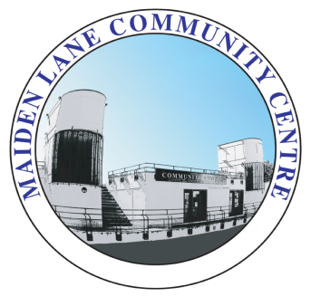

MAIDEN LANE PRE-SCHOOL EARLY YEARS PRACTITIONER
PERSON SPECIFICATION

The requirements listed below outline the shortlisting criteria used, so please ensure that you complete your application form fully explaining how you feel you meet each area of the criteria either through training undertaken or your experiences in the workplace. All successful applicants will need to meet the Essential Criteria.

ESSENTIAL CRITERIA

Qualification
NVQ Level 3 in Childcare

Knowledge/Experience/Training
- Post qualification experience in a group setting working with children under 5 years.
- Child protection/safeguarding training
- Experience knowledge and understanding of the Early Years Foundation Stage framework
- Complete knowledge and understanding of child protection and safeguarding procedures
- Ability to use a range of IT software packages

Skills/Abilities
- Ability to communicate effectively, verbally and in writing
- Ability of work effectively with parents and carers
- Ability to work in a busy, demanding environment
- Ability to model and promote safe working practice

Attitude
- Enthusiasm in providing the highest quality care and education
- Demonstrate high standards of safe working practice
- Ability to develop and maintain effective working relationships with colleagues, parents and outside agencies
- Demonstrate respect for appropriate boundaries

General
- Ability to maintain confidentiality at all times
- To keep abreast of all childcare legislation
- Demonstrate an understanding and commitment to equal opportunities

DESIRABLE CRITERIA
Training
- First Aid (Paediatric training)
- Health and Safety
- Equal Opportunities
- Working with Families training.

.

